Big Mountain Resort Ticket Price Analysis

# **Overview**

Big Mountain resorts boasts 105 trails with spectacular views of Glacier National Park and Flathead National Forest. About 350,000 visit the park every year of different skill levels. Recently Big Mountain installed an additional ski lift to increase distribution of visitors across the mountain, which carries an additional operating cost of $1,540,000 this season. To offset this cost, Big Mountain has increased their daily ticket rates but realize that may not be the best solution. The goal of this analysis was to create a data driven business strategy to determine the best Big Mountain resort can charge given the available facilities, as compared to other resorts ticket prices and available facilities.

# **Process**

## Data Collection/Cleaning

The process began with obtaining data from the Big Mountain Resort Database Manager. This data contained 27 data points for 330 resorts within the US (including Big Mountain). As this data included “State” names for each resort, our analysis incorporated State Population and Area data obtained from Wikipedia (<https://simple.wikipedia.org/w/index.php?title=List_of_U.S._states&oldid=7168473>). During the review of the data, it was identified that there was missing or incorrect information. Some data could be manually adjusted whereas others could not. Due to this some resorts were fully excluded from our data and some data points were dropped. The resulting data contained 25 data points for 277 resorts.

## Exploratory Data Analysis

After obtaining and cleaning the data, the next step was to perform some initial analysis. The findings indicate the following:

* Approximately 75% of the resort differences come from 2 features
* Approximately 95% of the resort differences come from 4 features
* Big Mountain resort can safely be compared to all other resorts, not just resorts within Montana.
* Features: Vertical Drop, Fast Quads, Runs and Total Chairs show a positive correlation with Ticket Price.

## Pre-Processing and Training

In this next step of the analysis, Big Mountain was removed from the data set and the data was then split using 30% for testing. The metric being examined in this process was the Price. Three Linear Models (R2, Mean Absolute Error and Mean Square Error) and the Random Forest Model were assessed using Cross Validation and the Random Forest Model had the least cross validation mean absolute error and also exhibited less variability.

# **Findings**

After determining that the Random Forest model best fit our needs, it was applied against all data (excluding Big Mountain) and then calculated what the Big Mountain Ticket should be. The results show that the Big Mountain Ticket price can be set at $95.87, the actual price is $81.00.

Given the 4 scenarios provided by the business, the model suggests the following:

1. Closing down up to 10 runs – this shows that closing more than 1 run will negatively impact Ticket Price and Revenue. 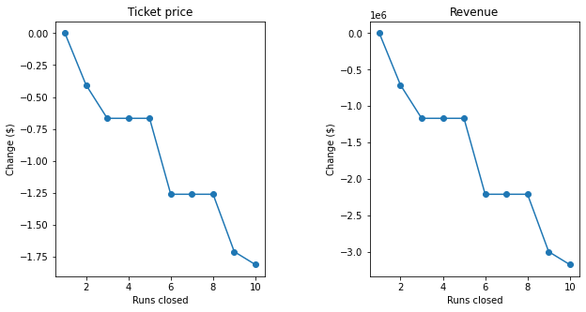
2. Add a run, increase vertical drop by 150 ft, install an additional chair lift – the model shows support for an increase in Ticket Price by $8.61
3. Same as 2 with an additional 2 acres snow making – this shows support for a Price increase of $9.90
4. Increase longest run by 0.2 miles and increase snow making capacity by 4 acres – this supports no change in Ticket Price

Based on the above, the best option would be scenario 2 which shows a significant price increase. Option 3 does show a slightly larger price increase however will also carry additional overhead costs for adding the 2 Acres of Snow Making.